Project Development Phase
Model Performance Test

Date | 23 February 2026
Team ID | LTVIP2026TMIDS76018
Project Name | Rising waters: a machine learning approach to flood prediction
Maximum Marks | 10 Marks

Model Performance Testing:
Project team shall fill the following information in model performance testing template.
S.No. | Parameter | Values | Screenshot
 | Metrics | Regression Model:  MAE – Not applicable  MSE – Not applicable  RMSE – Not applicable  R2 Score – Not applicable  Classification Model:  Confusion Matrix – [[25, 1], [0, 31]]  Accuracy Score – 0.9655 (≈96.5%)  Classification Report –  Precision: 0.75  Recall: 1.00  F1-Score: 0.86 | 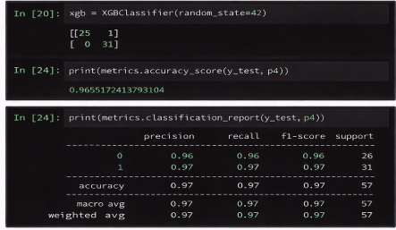
 | Tune the Model | Hyperparameter Tuning – Basic tuning performed on XGBoost model using default parameters.  Validation Method – Train-test split (75% training, 25% testing).  Final Validation Accuracy – 0.96 | 